Classwork on Looping.

Question: Write a program that will allow the user to enter a number. The program should output whether or not the number is a prime number.

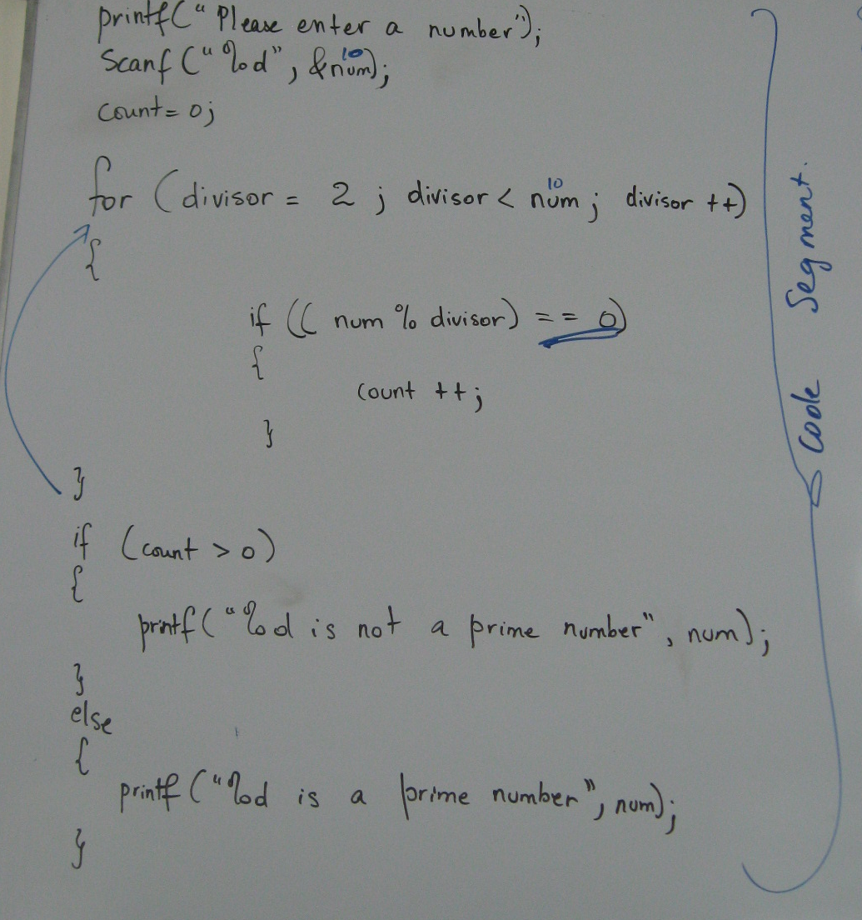

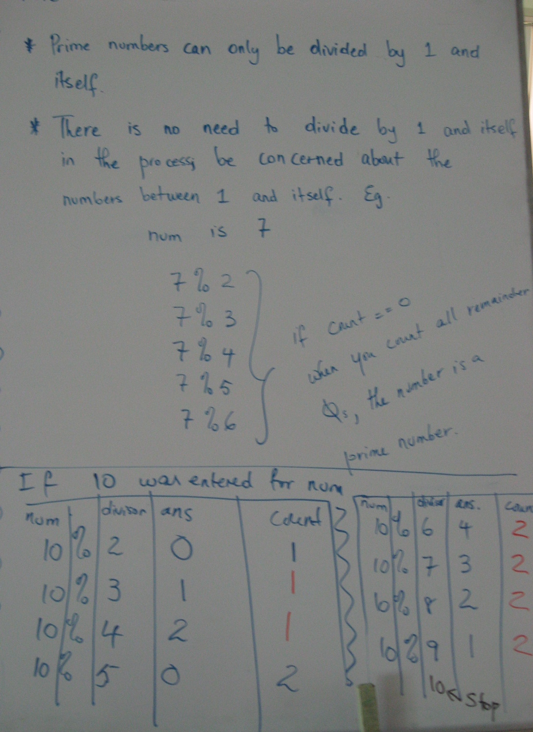

Question: Write a C program to show all prime numbers between 1 and 100.

#include<stdio.h>
#include<conio.h>

int main()
{

for (int num = 1; num <= 100; num++)
{
int count = 0;
for (int divisor = 2; divisor < num; divisor++)
{
if ((num%divisor) == 0)
{
count ++;

}
}

if (count == 0)
{
printf("%d\n", num);
}
}
getch();
return 0;
}

